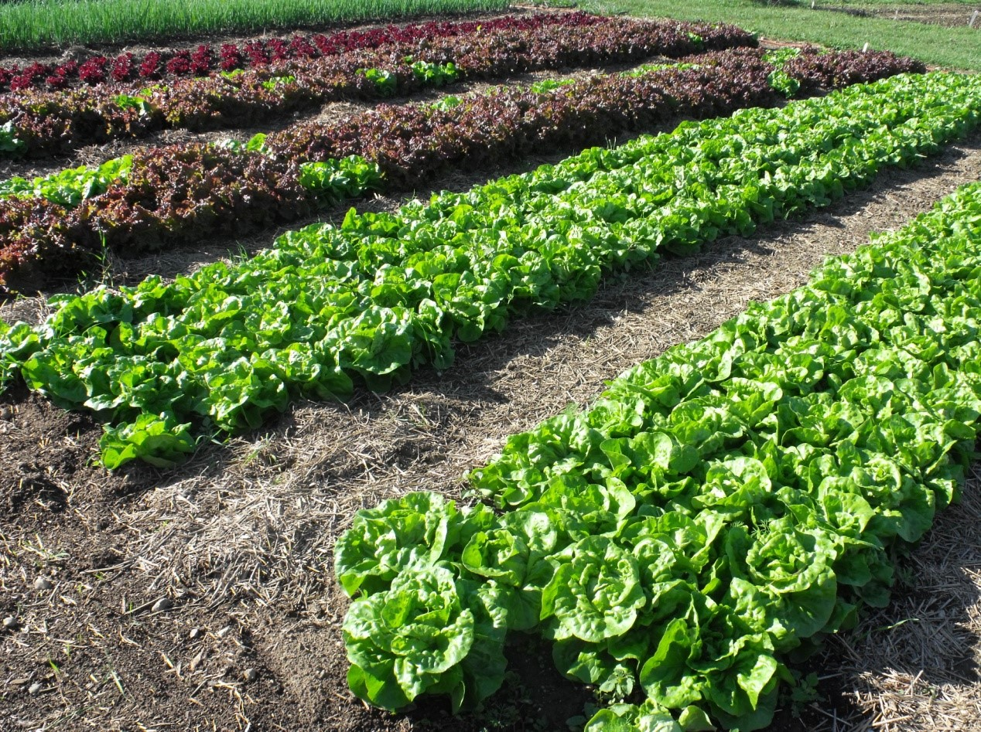

***everybody****eats*

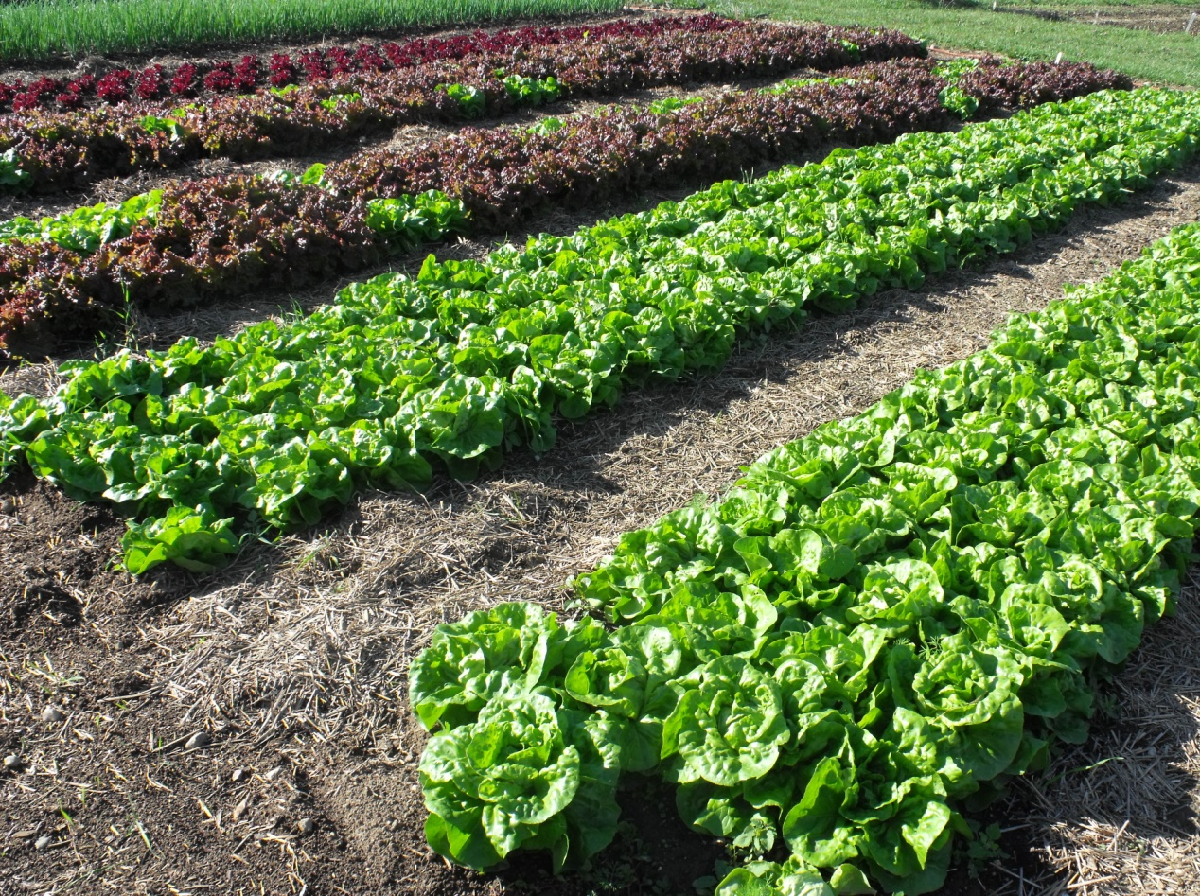

**FIVE**

Issue

***Sponsor Form >>>***



***Why These Goals Matter***

Public and private efforts – farms, farmers markets, gardens, food hubs, co-ops, restaurants, numerous nonprofits – are working to make Lansing’s food system more self-sustaining and equitable. These projects also attend to health, nutrition (e.g., obesity) and food access, especially amongunderserved populations. Many projects pay particular attention to the production and consumption of fresh, locally-raised or locally-processed foods. As we reshape the food and farming landscape within the greater Lansing area, it is important to consider the processes being used as well as the policies being developed.

If we are serious about equity and sustainability, then concerns of land ownership (and resource distribution generally) are as important as concerns of land use. Labor relations are as critical as food quality. Neighborhood stability and place-making are as important as food availability. Civic engagement – personal and collective empowerment – is as critical as physical infrastructure and economic accountability. These concerns need to be a part of ongoing public conversations if we are to build and maintain an inclusive, democratic, and ethical food system. “Everybody Eats” jump-starts the conversation.

***A one-day conference for people who grow, produce, process, market, distribute, prepare or eat food (this means you).***

*Everybody Eats: Nourishing Our Neighbors*

*Saturday, March 19, 2016 at IHM-St. Casimir School*

***What is* Everybody Eats?**

Everybody Eats is a one-day conference with the goal of vitalizing food system awareness and reform. As its title suggests, the conference is open to anyone and everyone who eats. We expect 200-300 attendees—people from across the food system and the greater Lansing area. The keynote presentation and workshops will provide a public forum for:

* Understanding the contemporary food system, its shortcomings and its alternatives
* Discussing how ordinary people can assume control over the way their food is produced and distributed
* Understanding the barriers to food justice and food democracy in the greater Lansing area
* Increasing youth involvement in the food system
* Increasing employment opportunities for greater Lansing area residents via the food system
* Improving food access for individuals and populations in need in the greater Lansing area
* Recognizing how good food, public health, environmental health and social justice support each other
* Networking with people from across the greater Lansing area to place food at the heart of community-building and common wealth

**Preserving Partners: $1,000 - $2,500**

Acknowledged as a Sponsor of conference scholarships; Name/logo included on conference print materials;  
Announced at conference opening and closing; Complementary exhibit table at event (prior arrangements necessary);

Name/logo included on program

**Gracious Growers: $500 - $999**

Name/logo included on conference print materials; Announced at conference opening and closing;

Complementary exhibit table at event (prior arrangements necessary); Name/logo included on program

**Fruitful Farmers: $200 - $499**

Name/logo included on program; included on table display at conference;

Announced at conference opening and closing; Complementary exhibit table at event (prior arrangements necessary)

**Community Cultivators: $50 - $199**

Name/logo included on program and noted on table display at conference;

Complementary exhibit table at event (prior arrangements necessary)

***Sponsorship Information***

Your contributions to this community effort are encouraged and greatly appreciated! While some grant funds are available for the conference, in-kind and financial sponsorships are **critical**. We think our event aligns with your organizational goals, and **we would like to invite you to become a conference sponsor.**

**Your sponsorship will help cover the following costs:**

**Facilities & Services**

Costs essential to the event include facility and furniture rental, keynote honoraria, technical equipment and assistance, catering, tables, chairs and advertising.

**Scholarships**

The conference strives to include everyone who is interested in the greater Lansing area food system. We meet this goal by providing scholarships for those who cannot afford the registration fee. Sponsors can request that their contributions be used to fund conference scholarships. The sponsor may either identify a specific attendee(s) or provide an open scholarship that will be awarded based on need.

**Workshops**

Many workshops require special funding - for materials for travel reimbursement for facilitators who have travelled long distances. Sponsors may choose to provide support for a particular workshop or provide general support for the workshops.

**Make checks payable to Michigan State University**

**Michigan State University, East Lansing, MI 48824**

**For more information, email** [**kwhyte@msu.edu**](mailto:kwhyte@msu.edu) **or call 517-432-1034**

**www.every-body-eats.com & www.facebook.com/EverybodyEatsMI**

**www.every-body-ets.com**